Oracle Virtualbox Manager downloaded.

pfSense Firewall successfully installed.

Internet interface has an IP address of 10.0.2.15/24 while the internal network interface has an IP address of 192.168.1.1/24.

I checked for DNS (Domain Name Service) by using the command; nslookup. DNS is working.

Kali Linux virtual machine installation is complete and successful.

Kali Linux VM IP address.

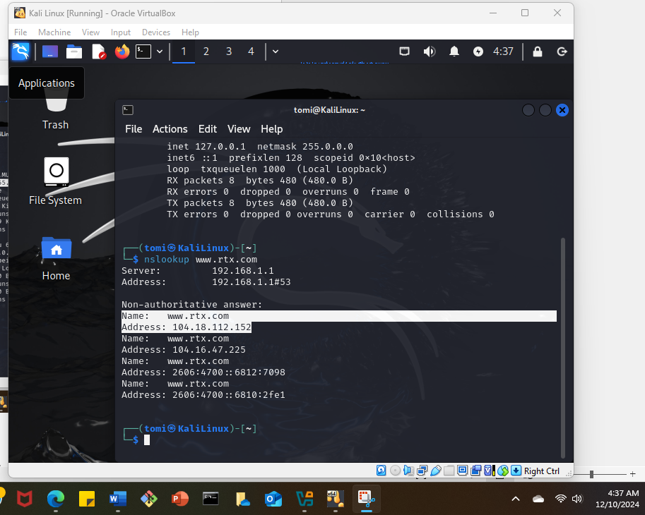

DNS is active on my KaliLinux VM.

Configured Kali Linux VM with a static IP address which is highlighted. I also checked if the DNS is active.

Installing the vulnerability scanner. I chose Greenbone Vulnerability Manager.

Installing gvm.

The installation could not be completed. The Run advised a command ‘sudo greenbone-feed-sync –type nvt.’

All this time, I have not figured out that the pfSense firewall was going off due to the low RAM on the host machine.

Trying out the command line highlighted.

I was still having the same output.

I was trying out various commands to troubleshoot.

Here, I was getting the error message that postgresql version available is 16 but I needed version 17.

After more troubleshooting I could still not start the postgresql service. The message was that version 17 was already existing.

I needed to stop version 17 and start it again in the main cluster.

Greenbone Vulnerability Scanner was successfully installed. A password was generated that I will need to be able to do a vulnerability scan.

The command ‘gvm-check-setup’ indicated a successful installation of the vulnerability scanner.

**Challenges and lessons learned.**

During this lab. I encountered a lot of issues. The kali Linux installation was smooth for me as I only needed to follow every step from the website. I decided to use GVM scanner but the installation was failing. I watched a lot of videos and did a lot of twerks on my VM configurations. I later realized that my firewall kept going off while trying to install the scanner and I also realized that my computer was running slower than usual.

My hardware RAM is only 8GB, the recommendation on the website was at least 16GB. My slow-running computer emanated from this. I needed to upgrade the host machine RAM so I upgraded to 32GB.